VPC -Task 02
- Create one VPC, with 1 public subnet and 1 private subnet
Create sample VPC
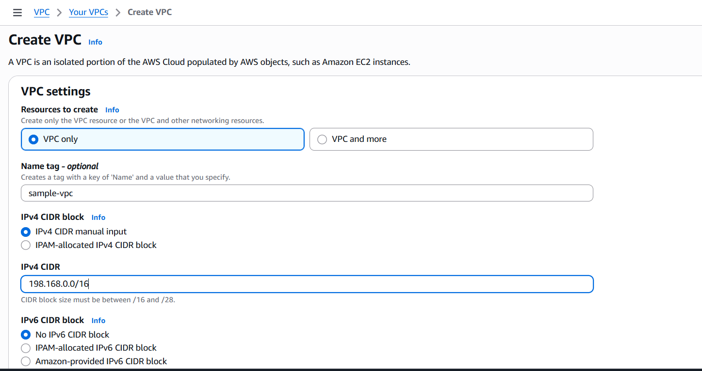
Then create one public and private subnet
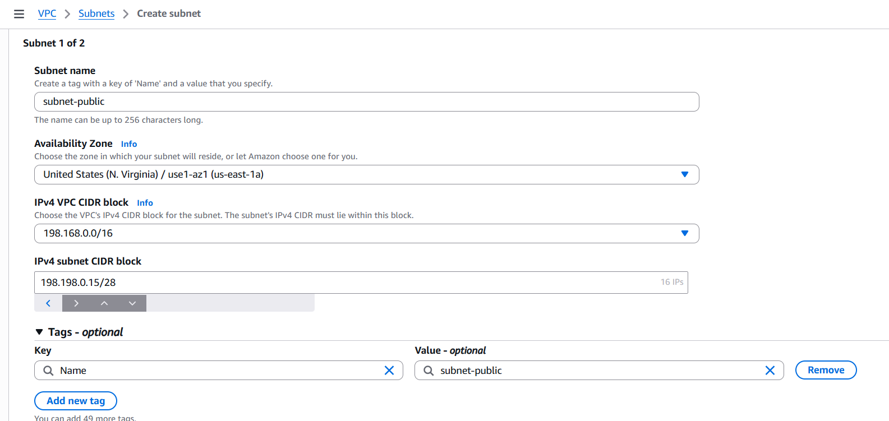
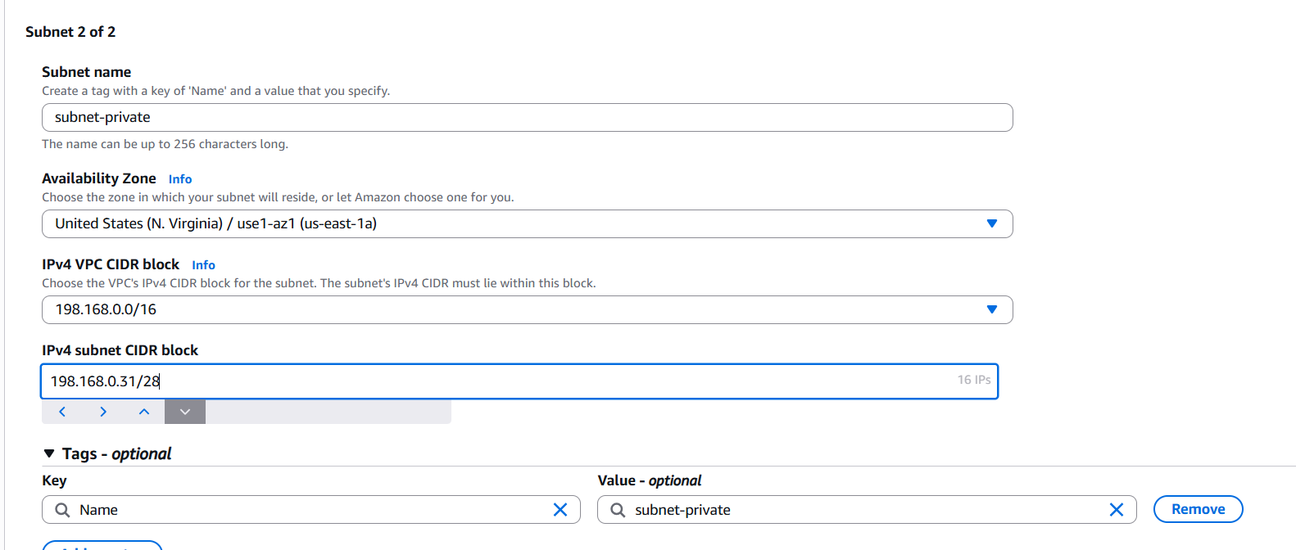
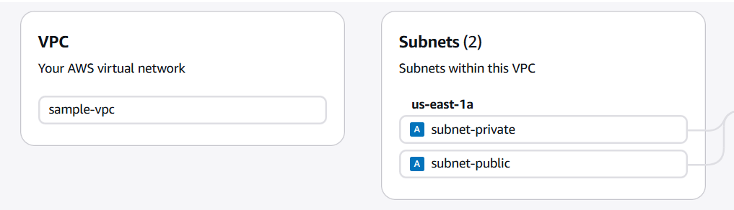
- Enable VPC peering for cross-region
Create VPC in north virigina and ohio
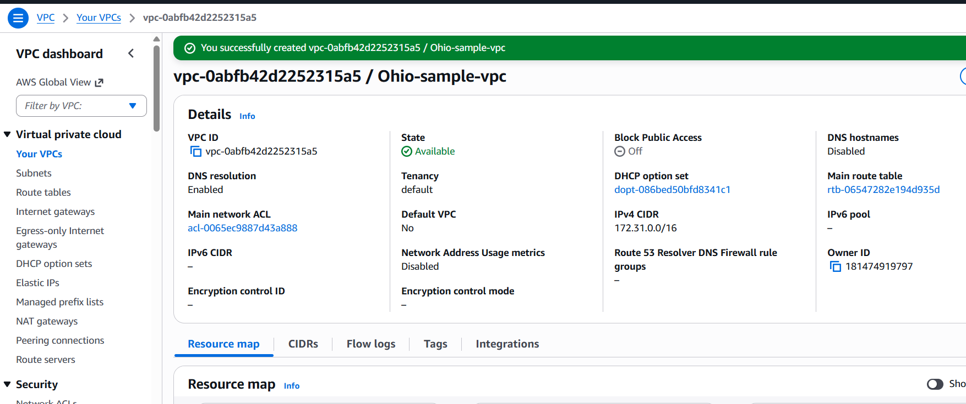
Now go to virginia task and click on peering connections,
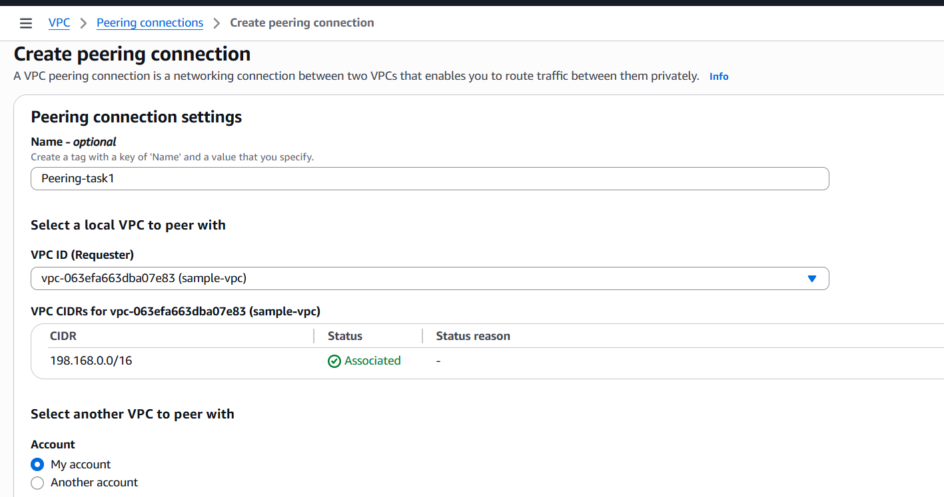
And provide the VPC id of ohio region and click on create
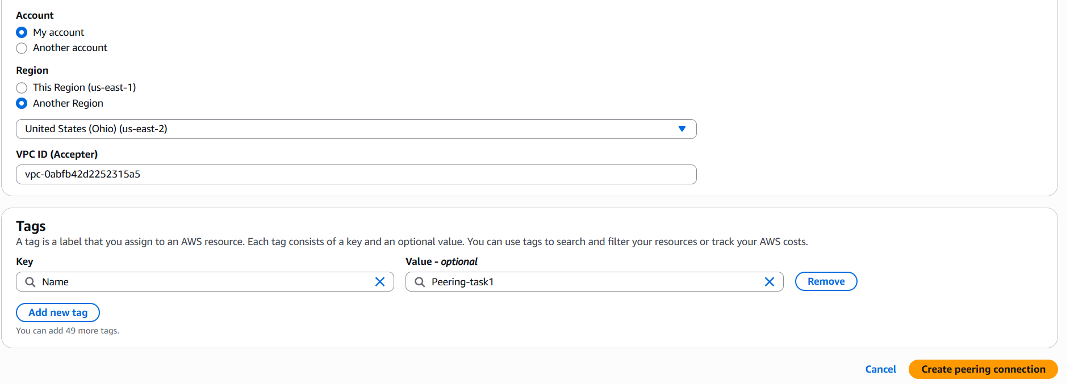
Then peering request will be assign from virgina and go to ohio region and accept the request
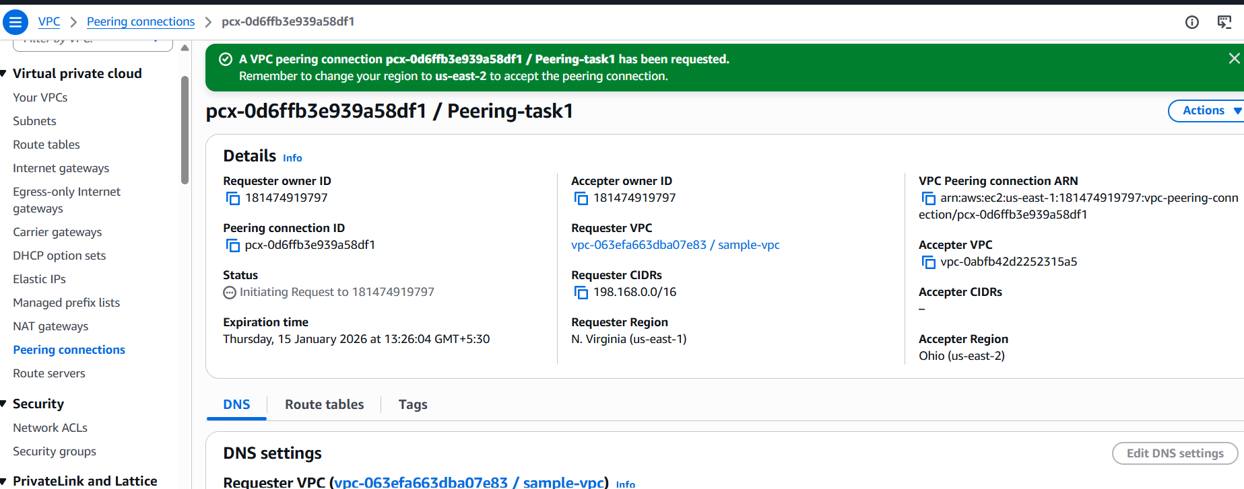
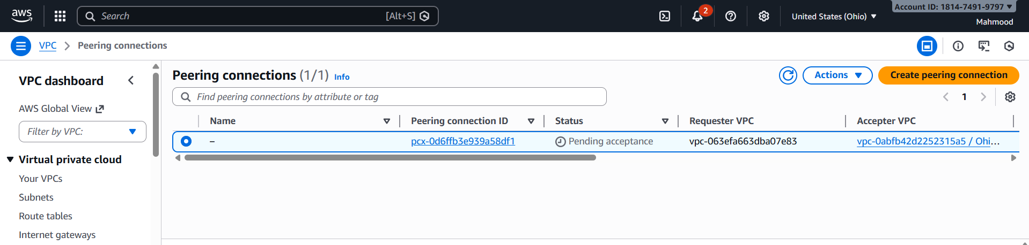
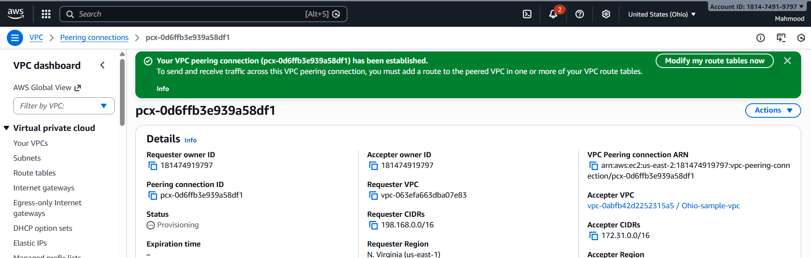
Add a route:
- Destination: the other VPC’s CIDR (e.g., 192.168.0.0/16)
- Target: the VPC Peering Connection ID
Do this in both VPCs.
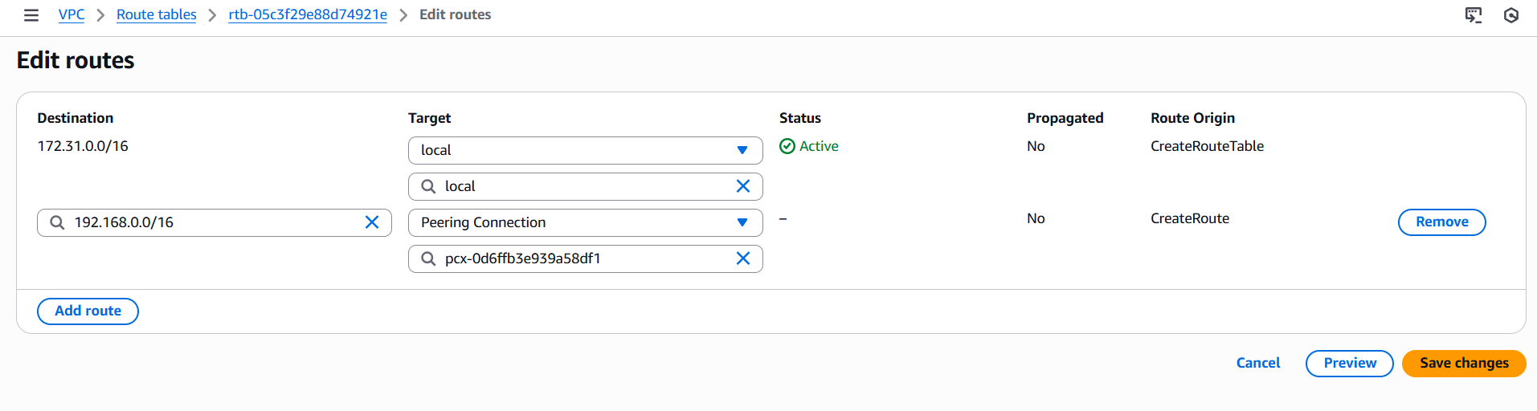
Launch EC2 instances in each VPC
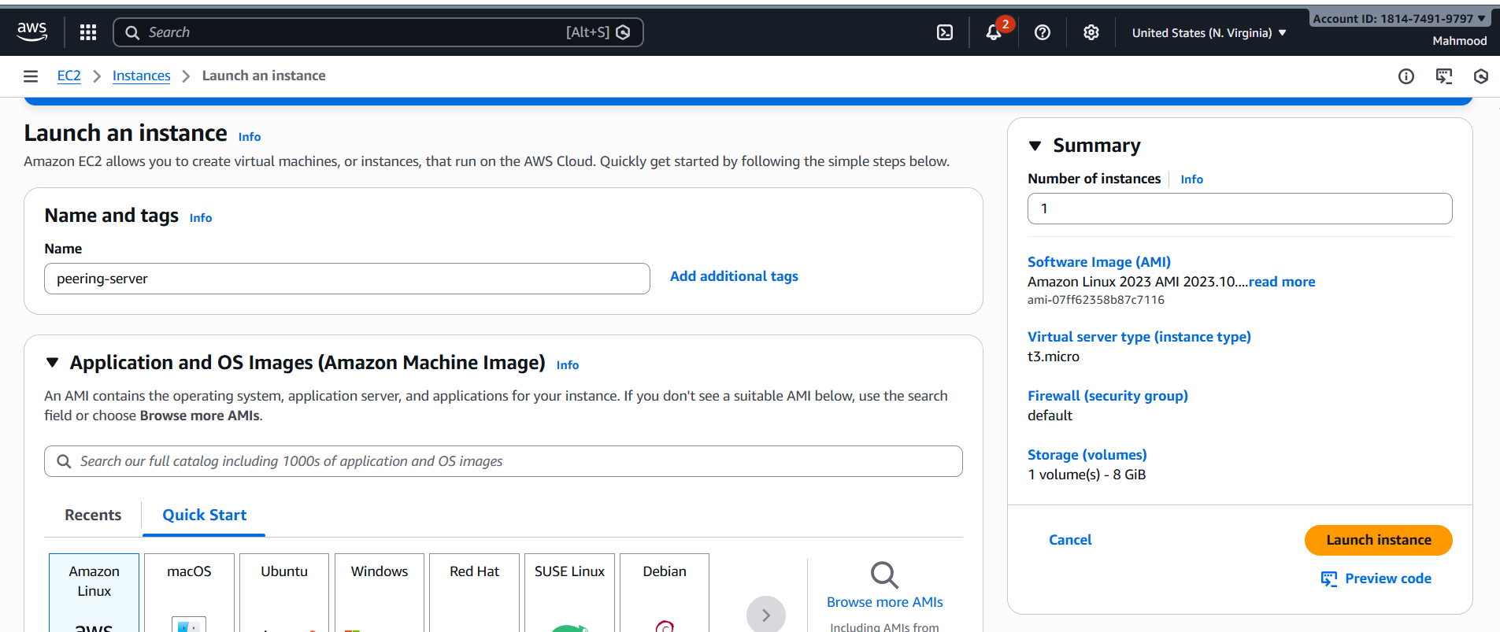
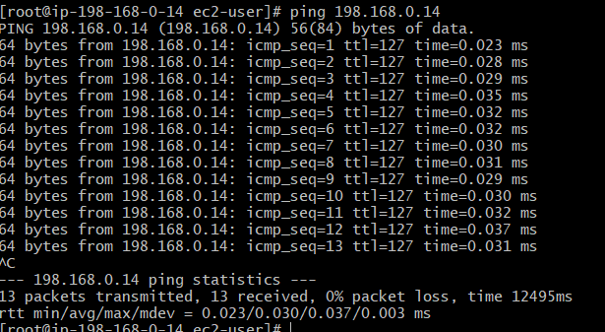
  - Enable VPC peering for cross-account
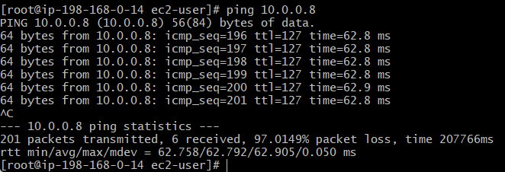
  - Set up a VPC Transit Gateway
Got to Vpc and click on Transit gateway and create it
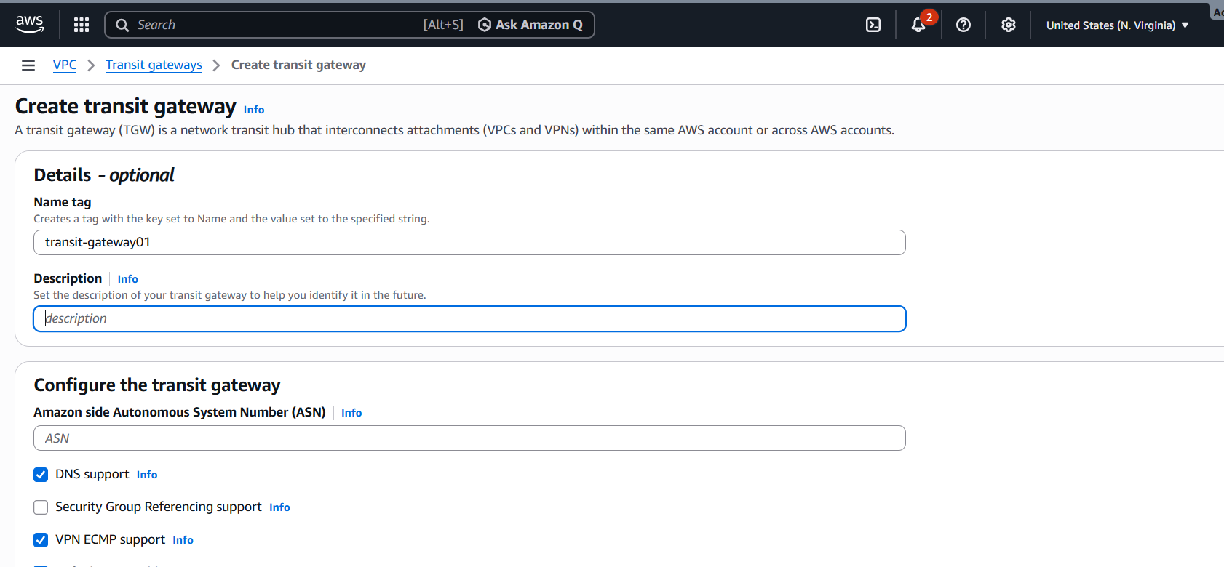
And again to vpc and select transit-gateway-attachments and create it
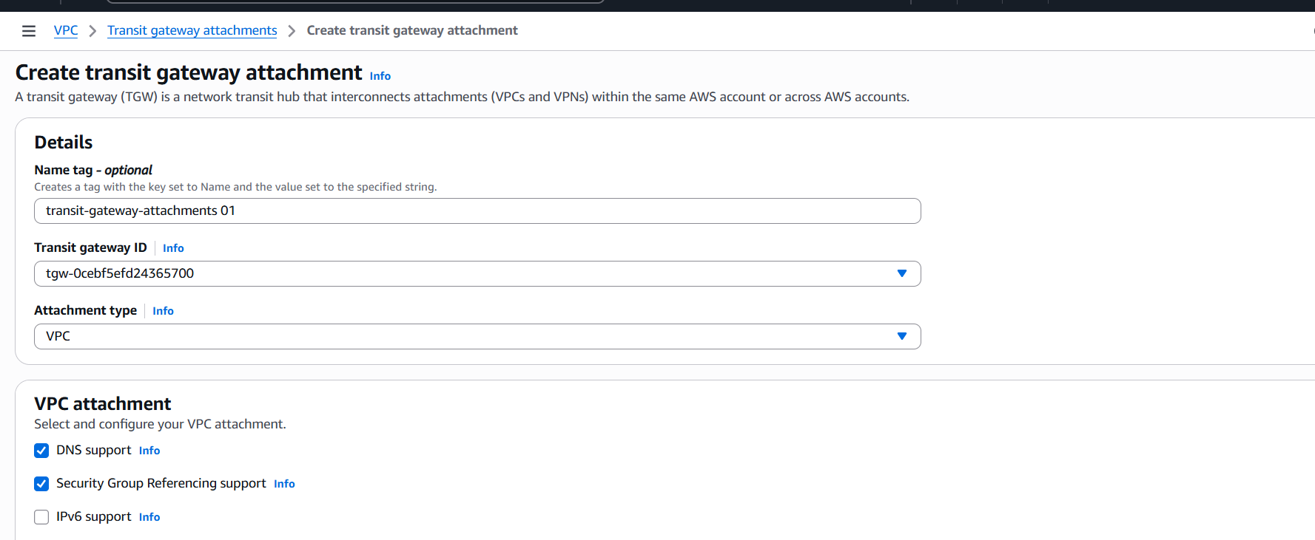
Now go to VPC and click on Route Tables and select the route and edit routes
Add a route for the destination CIDR of the other VPC, pointing to the Transit Gateway as the target.
E.g., if VPC A is 10.0.0.0/16 and VPC B is 192.168.0.0/16, then in VPC A’s route table add:
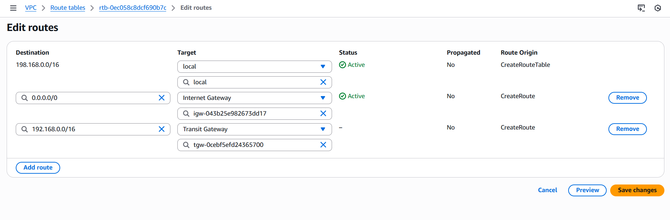
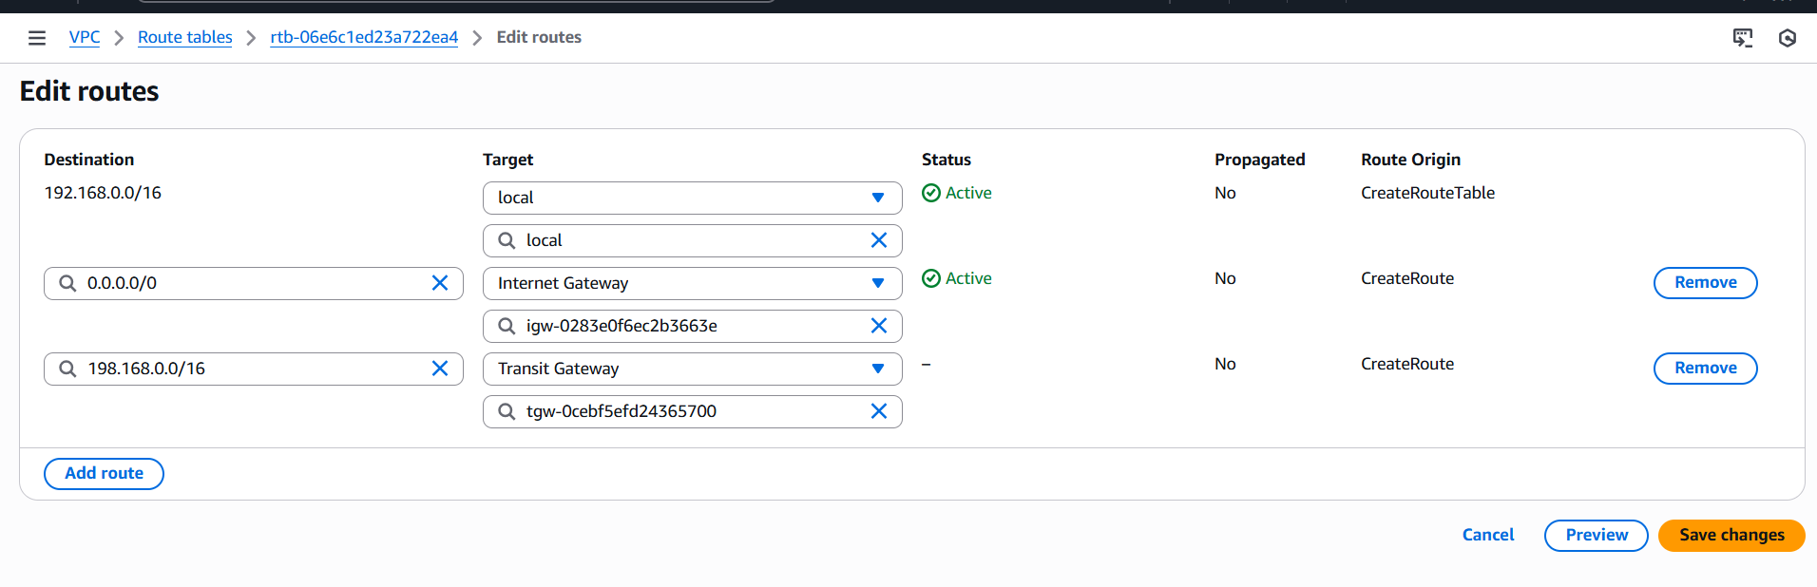
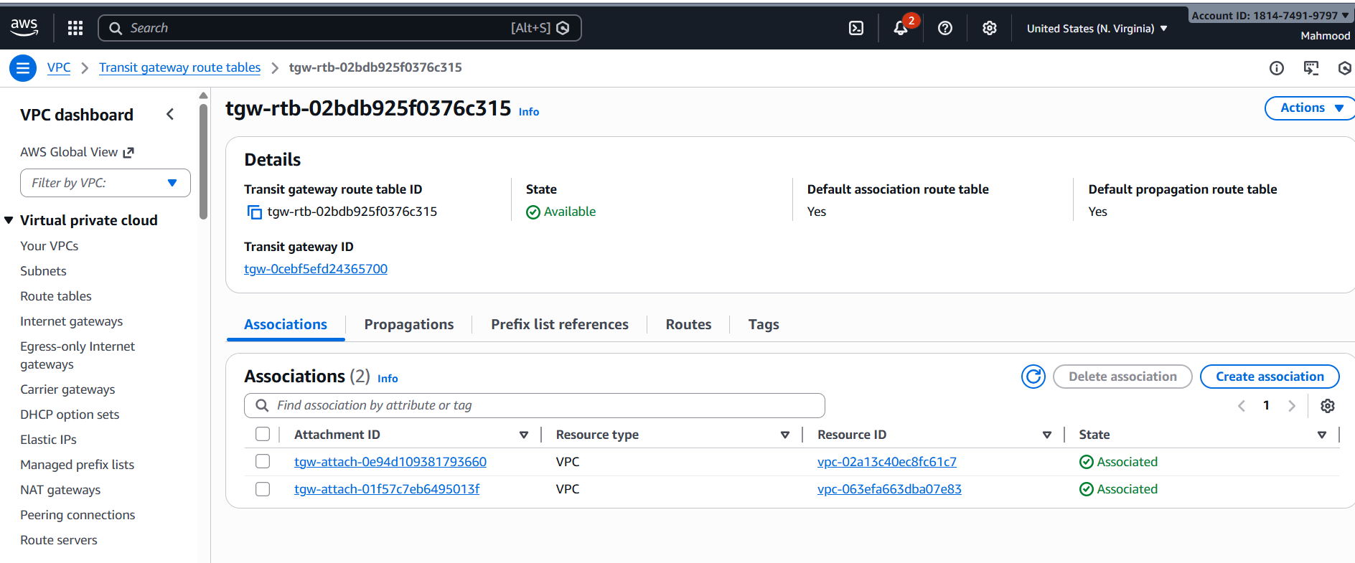
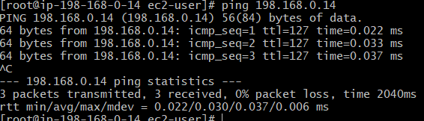
  - Set up a VPC Endpoint
Go to VPC select endpoint and create it
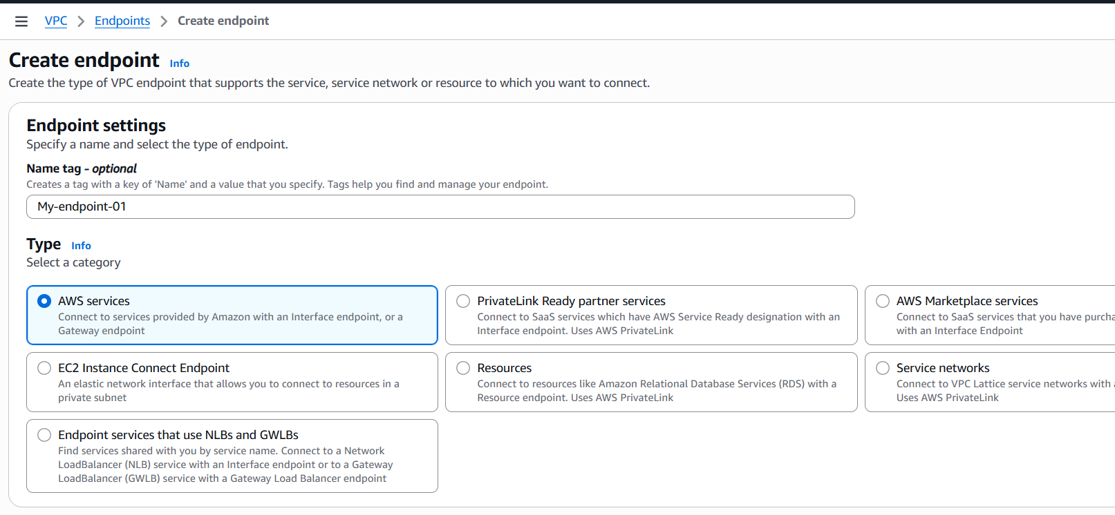
And select service as s3 and select VPC
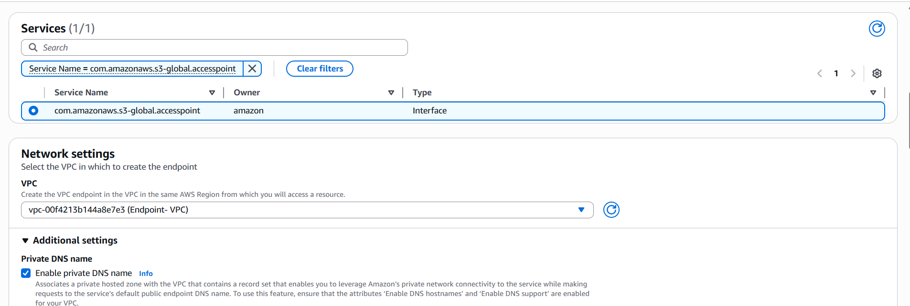
Then provide a subnet
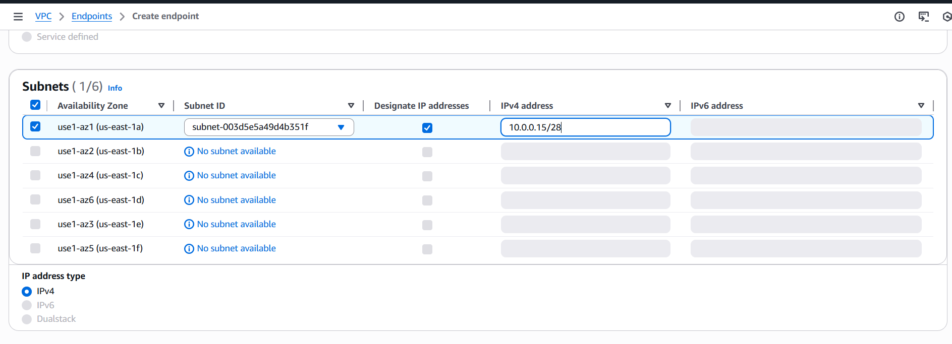
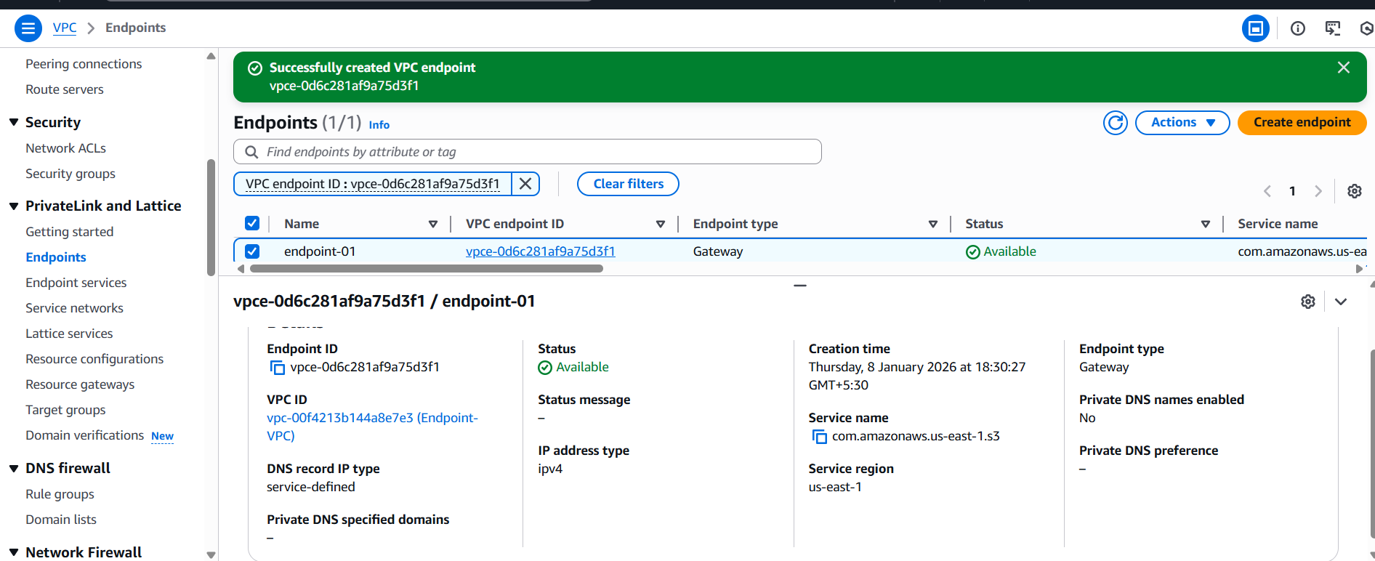
Now create a role with EC2 then click next
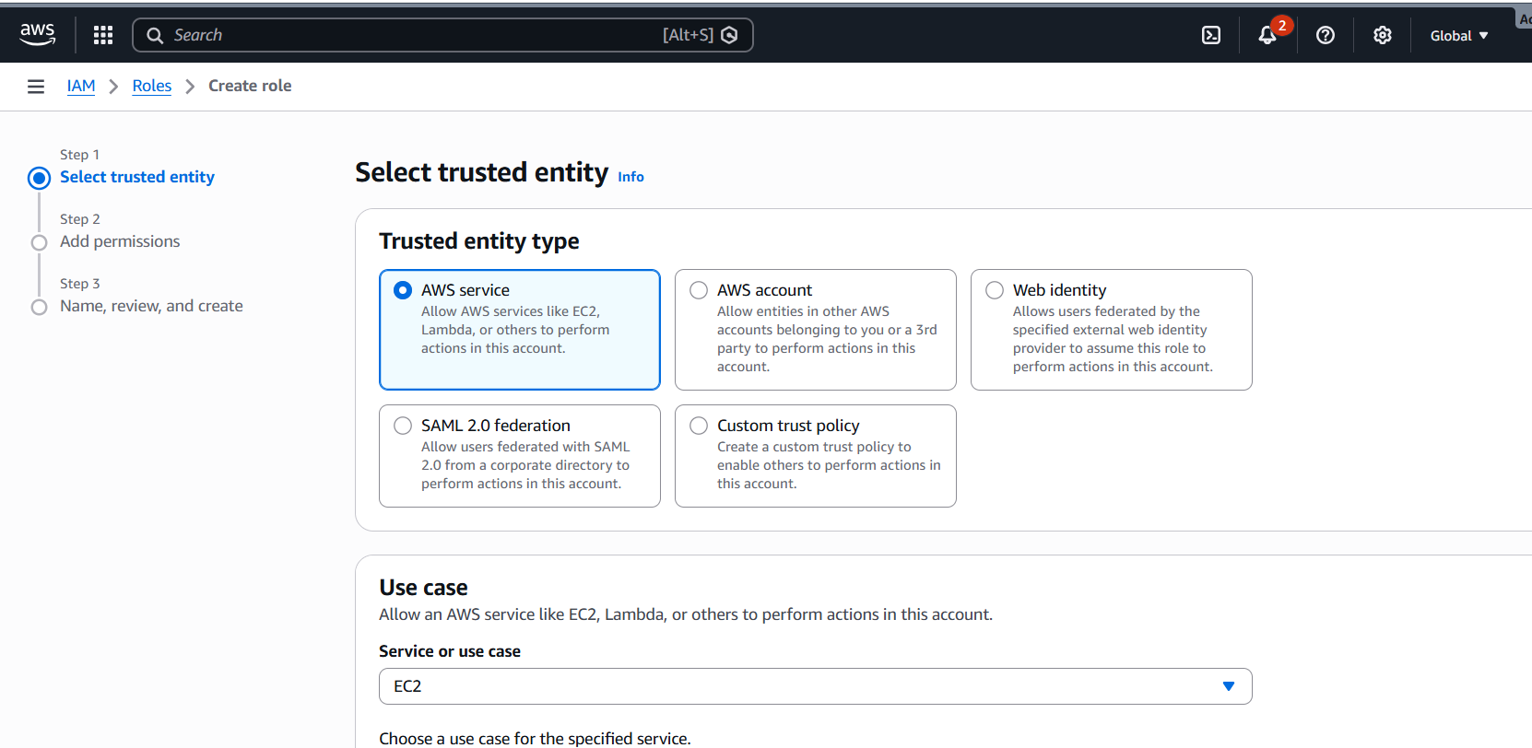
And select amazons3readonlyprocess for testing and create a role
Then Go to EC2 → Instances
Select your instance (ip-198-168-0-14)
Click Actions → Security → Modify IAM role
Select the role you created
Save
